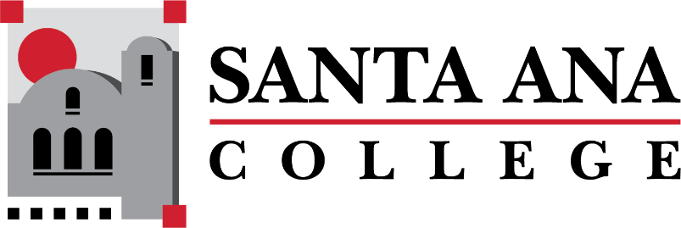
Dual Enrollment Workgroup Minutes
Tuesday, October 18, 2022 2:00-3:00pm., Hybrid
S-215 & Zoom
- Report out of the working subgroups
  - PD Workgroup: Faculty Handbook is being reviewed and revised. A concern was raised regarding students not being added to classes on time, mentioned a possible canvas training for Dual Enrollment. Coordination is coming along to roll out the updated faculty handbook by the end of the semester, if not sooner.
  - English – Learning 100 research skills as an opportunity for English 101 students as co-curricular option exploration in hopes of supporting success and completion. Non-Credit has an opportunity for High School partners to offer free courses in college level math/English preparation.
    - If high school partners are interested, please reach out to Dr. Nery
    - Mention of Non-Credit classes for parent orientations
    - Bridge courses to offer $150 Bookstore voucher
  - On Parent and Student Orientations: Information packet being sent out in Spanish and Vietnamese, packet recommendations to include:
      - Conduct/FERPA clearances (also include in summits for faculty)
      - Options for successful trade pathways (CTE) - Share details on the value of a certificate and cost sheets, pathways presentation of trades (welding, auto, etc.)
  - Positions are being filled to grow DuE and Admissions – Grant awarded (Director of DuE, Associate Dean of CEWD, etc.)
- Timelines:
  - Admissions and Records – Recommended timelines reflect a per school submission of special admits, 6 weeks prior to start of semester. Submit non-coordinated forms asap.
  - Basti Lopez – Met with Distance Education, edits being made for canvas/OTC training dates.
    - Dr. Jeffrey Lamb recommended incorporation of faculty evaluations within the timelines.
  - SAUSD/CTE/SAC merged timeline to be provided by Dr. Ortiz
- Timelines to have a leadership retreat/summit in June 2023, Dual Enrollment Summit to happen before the end of the Spring Semester (May) and a week before FLEX in the JSC. These retreats will help with evaluating what was completed in the year and potential next steps.

- Next Steps: Potential Solutions

  - Summits: Chairs, Admin, Deans, HS Partners, Workgroup Members
    - In JSC – Summer Retreat – 23/24 FY
    - In JSC – All day retreat, Last week of May
    - In JSC - All day retreat, a week before FLEX
    - Summit Topics:
      - FERPA Clearances– Faculty awareness if student has given permission/assigned another person to view grades.
      - Overall DuE evaluation and next steps
  - Spring Discussion with Senate in regards to compensation and role of faculty leads and mentor LHE.
  - Faculty and Classified – What resources are needed?
  - Dr. Nery and Edwin to meet for a strategy meeting.
  - Include Pilar in future DuE strategizing meetings.
  - Send Leisa Schumacher paperwork for mentorship compensation.
  - Career Exploration Fair to be offered in Spring 2023.

Upcoming Meetings: November 15, 2022

